Title of the assignment

By your name
Student ID:

An assignment submitted for the requirement of the course completion of BUS 500: Research Methods & Quantitative Analysis

Supervised By
Dr. Murad Ali

Fall 2020

FACULTY OF ECONOMIC AND ADMINISTRATION
KING ABDULAZIZ UNIVERSITY
JEDDAH- SAUDI ARABIA
Rabi'II 1441H – December 2019 G

Title of the paper

Authors names

Affiliations

Abstract

Start here ……..

Key words: Absorptive capacity; Innovation; Performance; PLS-SEM; fsQCA; Predictive analysis.

Introduction
Start here ……….

Theorical background and hypothesis development
  - Variable 1 definition (Absorptive capacity)
Start here ……….

  - Variable 2 definition (Organizational innovation)
Start here ……….

  - Variable 3 definition (Organizational performance)
Start here ……….
  - Variable 4 definition
Start here ……….

  - Variable 5 definition
Start here ……….

  - Hypothesis development

Acquisition, product innovation, process innovation and management innovation
Start here ……….

H1: Acquisition relates positively to product innovation, process innovation and management innovation.

Assimilation, product innovation, process innovation and management innovation
Start here ……….

H2: Assimilation relates positively to product innovation, process innovation and management innovation.

Transformation, product innovation, process innovation and management innovation
Start here ……….
H3: Transformation relates positively to product innovation, process innovation and management innovation.

Exploitation, product innovation, process innovation and management innovation
Start here ……….

H4: Exploitation relates positively to product innovation, process innovation and management innovation.

Relationship between product innovation organizational performance
H5: Product innovation relates positively to organizational performance.
Start here ……….

Relationship between process innovation and organizational performance
Start here ……….

H5: Process innovation relates positively to organizational performance.

Relationship between management innovation organizational performance
Start here ……….

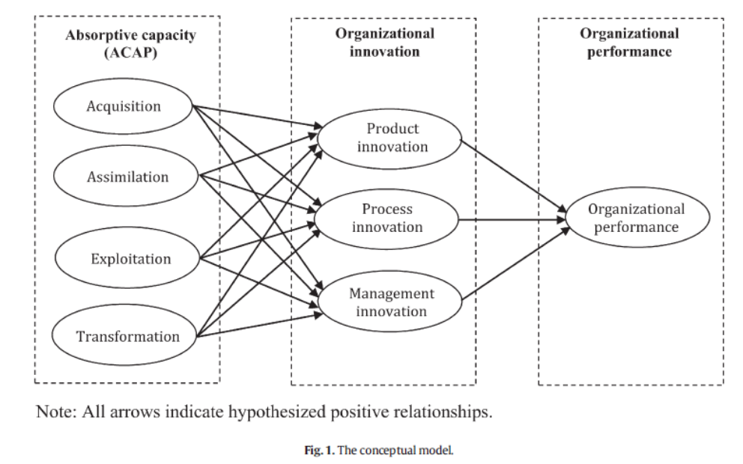
H5: Management innovation relates positively to organizational performance.

Research methodology
Start here………..This section consists a step-by-step methodological procedure used in this study (i.e., sample and data collection, instrumentation, the measurement model and structural model analysis) to test the research model.

  - Data collection and sample
Start here………..This study tests all the hypotheses using a sample of 347 large.

  - Measures
Start here…………This study adapts and uses existing validated scales for all the constructs. In this study, Section 2 provides a basis for the questionnaire design. All the items and responses appear on a five-point Likert-type scale ranging from “strongly disagree” (1) through “neither agree nor disagree” (3) to “strongly agree” (5). Table 1 summarizes the measurement items used in the study.

Table 1: Summary of measurement items (Optional)
Constructs | Variables | Items | Reference
KAC | Acquisition | 3 | Flatten et al. (2011)
KAC | Assimilation | 4 | Flatten et al. (2011)
KAC | Transformation | 4 | Flatten et al. (2011)
KAC | Exploitation | 3 | Flatten et al. (2011)
Organizational Structure | Centralization | 6 | Lee and Grover (2000); Liao et al. (2011)
Organizational Structure | Formalization | 3 | Lee and Grover (2000); Liao et al. (2011)
Organizational Structure | Complexity | 3 | Lee and Grover (2000); Liao et al. (2011)
Organizational Structure | Integration | 3 | Lee and Grover (2000); Liao et al. (2011)
External Environment | Customer | 4 | Kim (1976)
External Environment | Supplier | 5 | Kim (1976)
External Environment | Competitor | 3 | Kim (1976)
External Environment | Government | 4 | Kim (1976)
External Environment | Technological | 3 | Kim (1976)
Total |  | 48

  - Data analysis
Start here………..The research model of Figure 1 is analyzed by employing a PLS structural equation modeling tool or more specifically, SmartPLS package version 2.0.M3 (Ringle et al., 2005). It assesses the psychometric properties of the measurement model, and estimates the parameters of the structural model simultaneously. The following points summarize why this study considers PLS instead of LISREL or AMOS as a more appropriate statistical technique:

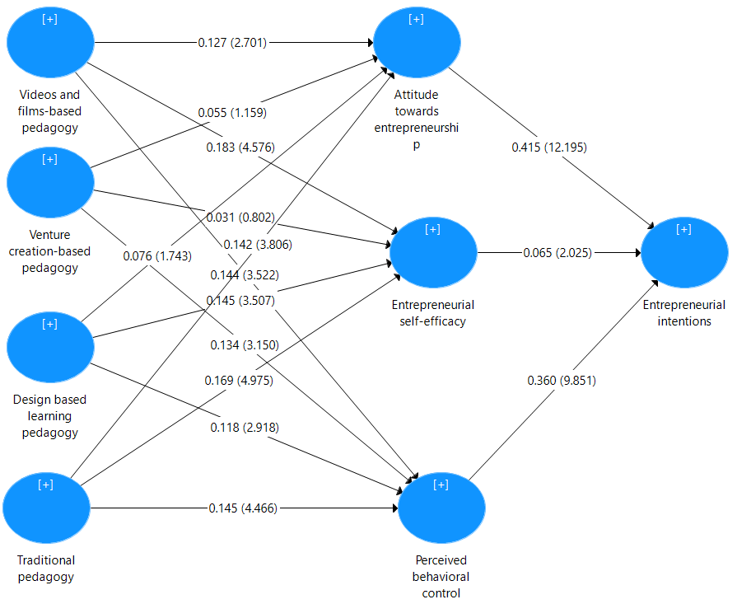
Note: All arrows indicate hypothesized positive relationships. In the in parenthesis, t-vales are reported. │t│≥ 1.65 at p 0.05 level; │t│≥ 2.33 at p 0.01 level; │t│≥ 3.09 at p 0.001 level
Figure 2: Structural model results

Results
Two steps are involved to analyze and interpret the results in PLS model. 1). the assessment of the measurement model and 2) testing of the structural model.

  - The assessment of the measurement model
The assessment of the measurement model calculates individual factor and cross loadings, Cronbach alphas, composite reliability, convergent validity (average variance extract or AVE), interconstruct correlations, latent variables scores. Results show that the measurement model meets all minimum requirements as shown in Table 2. First, the model satisfies the

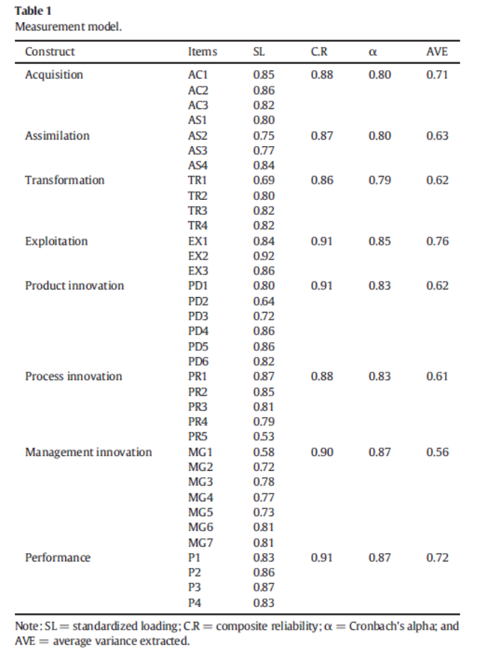

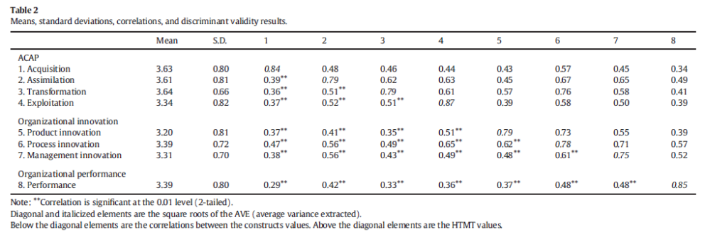

  - Testing of the structural model
Start here…………

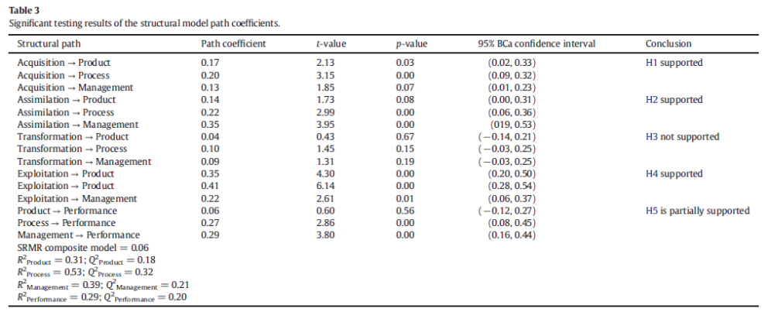

Discussion, conclusion, limitations and future research

Discussion of results
Start here…………

Theoretical contributions
Start here…………

Managerial contributions
Start here…………

Limitations and future work
Start here…………

References
Ali, M., Kan, K. A. S., & Sarstedt, M. (2016). Direct and configurational paths of absorptive capacity and organizational innovation to successful organizational performance. Journal of Business Research, 69(11), 5317-5323.
Ali, M., & Park, K. (2016). The mediating role of an innovative culture in the relationship between absorptive capacity and technical and non-technical innovation. Journal of Business Research, 69(5), 1669-1675.
Ali, M., Ali, I., Al-Maimani, K. A., & Park, K. (2018). The effect of organizational structure on absorptive capacity in single and dual learning modes. Journal of Innovation & Knowledge, 3(3), 108-114.
Ali, M., Sheikh, A. Z., Ali, I., Jinji, P., & Sumbal, M. S. (2020). The moderating effect of supervisor–subordinate guanxi on the relationship between transformational leadership and organizational effectiveness. Journal of East-West Business, 26(2), 161-192.
Ali, M., Ali, I., Albort-Morant, G., & Leal-Rodríguez, A. L. (2020). How do job insecurity and perceived well-being affect expatriate employees’ willingness to share or hide knowledge?. International Entrepreneurship and Management Journal, 1-26.

